PA B2-1: LOOPS
TOPIC
3
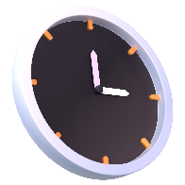
TIME TO COMPLETE: 1 HOUR

Write your responses to parts 2 and 4 in a word document. Make sure to include your name and the programming assignment number. Your code can be uploaded alongside the accompanying word document.

PART 1: PROBLEM STATEMENT
I have a special condition called readingonlyoneletterperlineosis. It has been a challenge my entire life, and I need your help. I need you to write a program that will take input from the user to allow them to enter as many words as the user would like and display them one letter per line.
Maybe next time we can look at a way to treat this condition at its source, but for now this is all I can manage. Thank you for your help.

PART 2: BRAINSTORMING THE ALGORITHM
- How do you plan to allow users to input as many words as they would like into the program before it ends? [10]

- How do you plan to display the characters of the input words one per line? [10]

- What specific program structures (if statements, loops) do you plan to use in the creation of this program and how? [5]

PART 3: WRITE THE PROGRAM
Write your code in a .py file using no dependencies (using other libraries or programs). Feel free to use the IDE of your preference, but ensure you only upload the .py file (alongside the answers to the questions in this document).
Your program will need to take input for as many words as the user would like to enter. Ensure that your submission adheres to the FIVE LAWS OF CODECRAFT.
Example output is provided below.
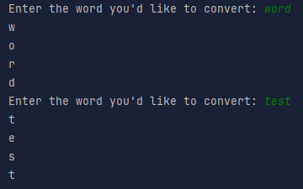
Upload the .py file with your program to ManageBac. [45]

PART 4: REFLECTION
Answer the following questions in the "Programming Assignment Documentation Template" that can be found in ManageBac.
- Did your final project match up with your idea from the brainstorming phase? If not, what changed? [5]

- How did you obtain the information from the user about how many times to ask for words? [10]

- How did you successfully print out each character on an individual line? [10]

- List any sources used in the creation of your program and how you used them. [5]

